Matthew Ford

1. Made all of my inputs in my “new” model the same as the last “transient” assignment model. Only thing I changed was dz is now 100 instead of 10. My well is also at the center of the domain 25,25. My new model is 3 layers with a confining middle layer with a low K. I had to change the constant head at the RHS to 40 instead of 30 otherwise MODFLOW wouldn’t run. Ended up having to change the horizontal K to 1 m/d instead of 0.1 to not dewater the domain past the confined layer. I have no recharge over the domain.
2. My thought how to integrate the transient model into my steady state model was to pump the transient model at the given rate of 500 m^3/day for the given times periods of 25,50,75,100 years and see the head response. I can then adjust the pumping rate to match that head response as we did in assignment 7. I will then take those pumping rates into my new model and use them to simulate capture for the given years. The models are slightly different but this should give us a rough estimate.
3. Here are the figures with head at the well to figure out an avg once reaching steady state. (25 years is before reaching steady state be we will do our best). As determined in assignment 7 this model reaches steady state after 43 years so the heads to match for >50yrs should be around 37.75 m. It looks like the head to match for the 25 year scenario is around 38.25 m.   
     
     
     
     
     
     
     
     
     
     
     
     
     
     
     
     
     
     
     
     
     
     
     
     
     
     
   A pumping rate of 260 m^3/day matches the head for >50 yrs according to our analysis. 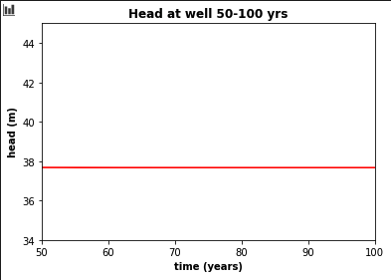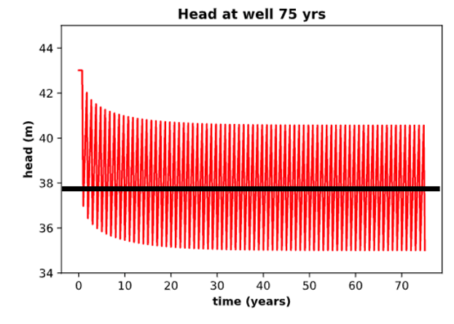

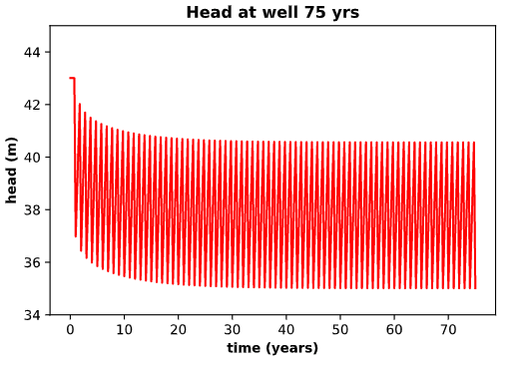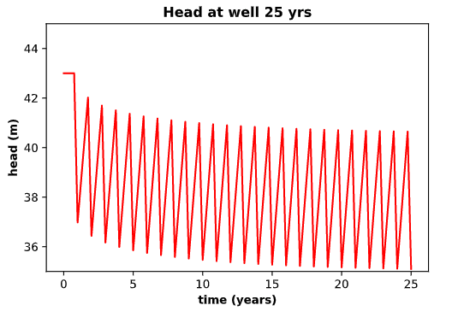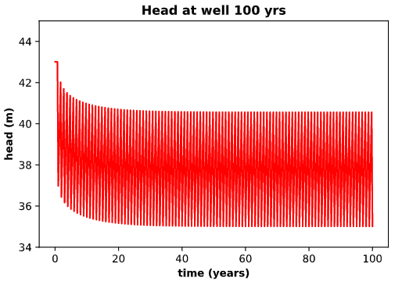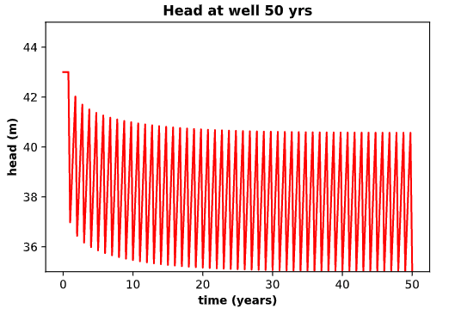

A pumping rate of 240 m^3/day seems to match the head for 25 yrs.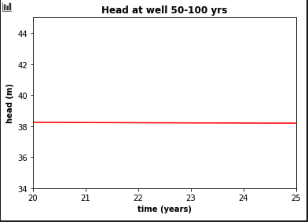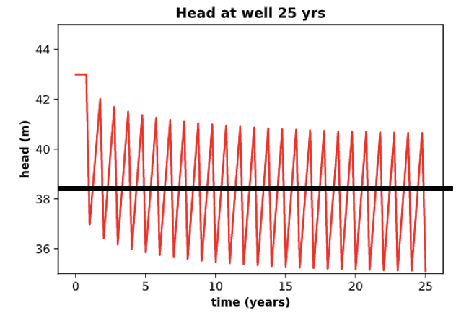

1. Now I will take those pumping rates of 240 m^3/day and 260 m^3/day and apply them to my model to see how capture changes.   
     
   **240 m^3/day**  
   As we can see at a pumping rate of 240 m^3/day no water from the boundary is captured from the surface layer but there is capture from the boundary in the confined layer.

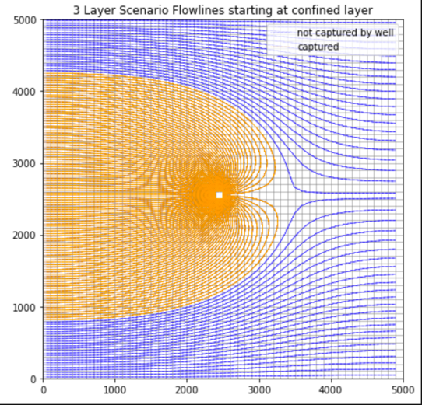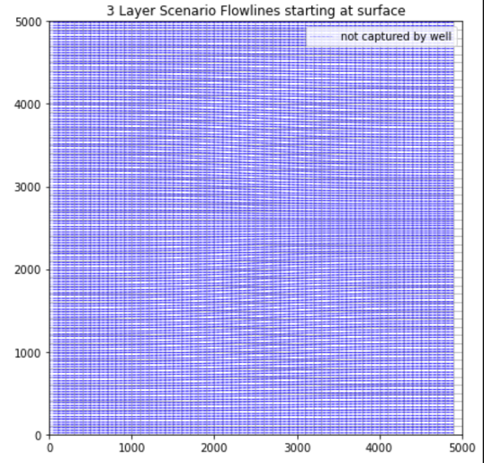

**260 m^3/day**

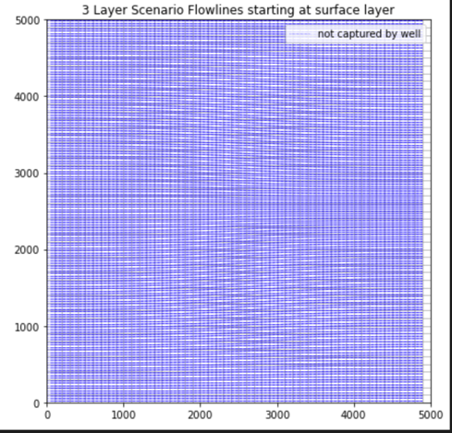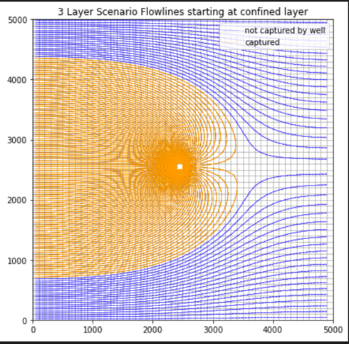

As we can see increasing the pumping rate by 20 m^3/day does NOT make any boundary particles reach the well when starting at the surface. We can see that the capture zone is slightly larger in the graph with the particles starting in the confined layer.   
  
Due to the properties of the confining layer and the small pumping rate no particles from the boundary surface reach the well. This is important if some sort of contaminant is dropped into the subsurface in the upper most layer at the boundary. This would be a safe pumping rate for the confined aquifer to never see that contaminant in the well. Well is SAFE to drink from!

After messing around with the pumping rate, a rate of 450 m^3/day would cause particles from the surface layer at the boundary to reach the well. 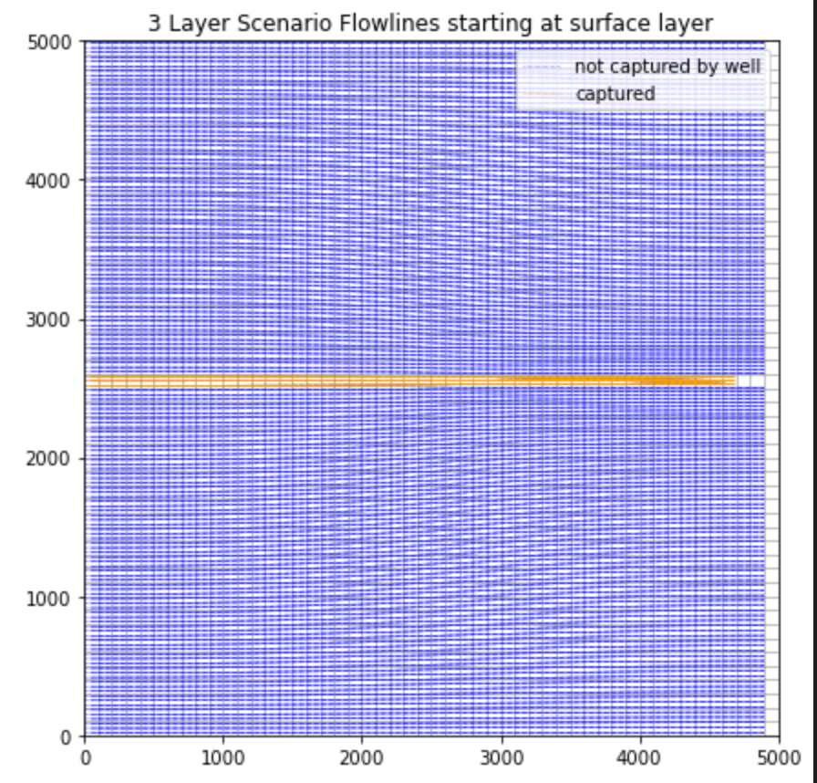

1. After talking with Ty I was assigned a new challenge to add an abandoned well which penetrates through the confined layer. For this I added a variable in the confining layer I made it 1 cell in size and made the K_horiz= 1 m/d which is the same as the rest of the domain. For this abandoned well I changed the K_vert = 1 m/d when the rest of the domains are 0.1 m/d and the confining layer is even smaller. I chose this value to represent an open well hole and it is likely to small for a real situation but also choosing 1 which is 10 m x 10 m is much larger than an actual borehole. Again in our situation the well is only screened in the bottom layer below the confining layer but this abandoned borehole now presents a “window” connecting the top and bottom aquifers.

When placing the abandoned well @ x=15, y=35 and using either our 240 or 260 m^3/day pumping rate equivalent to our 25-100 year steady state simulations we can see flowlines from the left boundary do travel down through the borehole and into the confined aquifer. 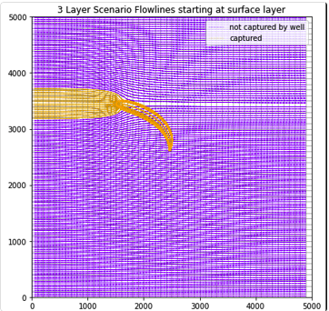

An interesting idea I had was to move the abandoned borehole “past” our pumping well which is located at the center of the domain. Now placing the borehole at x=40, y=35 there is some drawdown pulling the water into the confined layer but there is no capture in the well, meaning that water still moves to the right boundary.

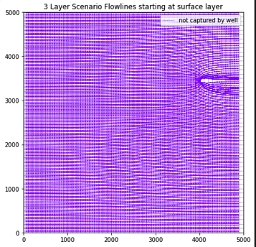

The next idea I had was at the x=40, y=35 borehole location what would the pumping rate need to be with the well at the center to reverse the gradient in the bottom most layer and capture particles. The pumping rate was 335 m^3/day. We can also see the head distribution in the confined layer and how the gradient is reversed enough for 1 flowline to get through.

